|  |  |  |  |
| --- | --- | --- | --- |
| **AcademicYear:2023-24** | **Project Synopsis** | | **Sem-V** |
| **Department:Computer Science and Engineering** | | **DateofPreparation:** |
| RollNo | 3043,3044,3045,3046 | Class | TY B.Tech |
| ProjectTitle | FARM-TECH | | |
| StudentName | 1. Deshmukh Radhika Ravindra. 2. Jadhav Kiran Popat. 3. Patil Samruddhi Pramod. 4. Rajmane Shruti Shankar. | | |

# Introduction:

In this website, we are giving detailed information about the Agriculture and its operations. The website is designed in an interactive manner and is able to give the farmers the knowledge for better quality crops and best sale price**.** Our website also helps to connect farmer with the new technology and make farming task simpler.

A different section has been provided for contacting the customers for different types of grains, vegetables, and fruits.Farmers can connect to the world via technology and can export agro products. Water scarcity farming can be achieved because of our FARM-TECH project.Farmer’s is online shopping website Where buyer can buy farm produce directly from farmers.Farming system is define as a complex inter related matrix of Soil , plant , animals , implements ,power , labor capital and other inputs controlled in part by farming families and influenced to varying degree by political , economic, institutional and social forces that operate at many levels.

.

.

# Literature Review:

|  |  |  |  |  |
| --- | --- | --- | --- | --- |
| **Sr.NO** | **Title of the paper** | **Authors** | **Publisher** | **PaperGist** |
| 1 | Online Farming  System | NingingGe, Hui Li, LingwangGao,IP Mist Lab ,College of Agriculture and Biotechnology China Agricultural Unveristy , Beijing, P.R.China | IEEE(2010) | The Present era is the modern age information technology has A huge contribution in this modernage.most people in the world now rely on information online. And Bangladesh is the main country now depend on Agriculture .In the past people on our countryused to grow crops based on information available from TV and radio. |
| 2 | Online Farming  System | K. SathishKannan,  G. Thilagavathi | IEEE(2013) | Farming System does not provide proper guidance to formers how to sell their product through online. The current system does not provide classes to formers to get knowledge about how to operate computer.  The current system does not providing courses to learn basics of how to register into sites, sell crops and transaction,The Current System does not provide website to farmers in their local languages. |
| 3 | Online Farming System | Abhishek A. G.  Department of Information Technology, Ishvari Engineering College, Chennai, India  [agabishek@gmail.com](mailto:agabishek@gmail.com) | IEEE(2016) | The smart farming system should be used so that the farmers can easily get all the information from the farm.farmers will be able to accessallagriculture-related information from the smart farming system, not just from any past of the.we talked to ordinary farmers and agricultural entrepreneurs ,about the art farming system and they welcome the initiative . |

* **Relevance of the Work:**

Online Farming System can lead to error free , secure , reliable and fast management system. It can assist the user to concentrate e on their other activities rather to concentrate on the record keeping. Thus it will help organization in better utilization of resources.The organization can maintain computerized records without redundant entries. That means that oneneed not be distracted by information that is not relevant, while being able to reach the information n. The Farming system can be entered using a user id and password. It is accessible either by Farmer or admin . Only they can add data into the database. The data can be retrievedeasily. The interface is very user-friendly. The data are well protected for personal use and makes the data processing very fast. This project has been develop during HTML, CSS language as a front end and back end as HTML my admin.

# Proposed Work:

Developing an online Farming system involves various components and considerations.

Here’s proposed outline of the work involved in creating such a system:

1. Needs Assessment and Planning: identify the specific needs of the target audience (small-scale farmers.Large-scale commercial farms, etc.).
2. Technology Stack: Choose the appropriate technology stack for the system , including programming

Languages, database, and web development frameworks.

1. Data Collection and sensors: Select and deploy sensors and data collection devices for monitoring soil conditions, Weather, crop health, and other relevant parameters.
2. Data Processing and Analysis: Develop algorithms and data processing pipelines to analyze the collected data.
3. User Interface (UI) and User Experience (UX): Design an intuitive and user-friendly web or mobile interface for farmers to interact with the system.

# Proposed Methodology:

This project develops “online farming system” website to provide farmer management. We will Discuss on our project topic and consider input and output. To develop our project we use HTML and CSSprogramming language. First discussed with our guide for selecting the topic and then we collect the information about the project .After collecting the information, we analyzed the project. Then we made theplan to implement the project design .After that design we would start to implementing the project coding andexecution. We have used HTML and CSS MY ADMIN database for creation of this website. Firstly wedecide project plan and depending on that plan we created this website. We have divide our project intomodules such as Admin login module, farmer login module, farmer type, Farmer management module etc.Then after we start the testing of project after successfully completion of our project we submit our project.

# HW/SWRequirement:

1. **Hardware:**
   * Processor-i5
   * Hard Disk-5GB
   * Memory-1GBRAM**.**

# Software:

* + OperatingSystem- Windows11andAbove
  + XAMPP server
  + Visual Studio Code.

# ProgrammingLanguages:

* + HTML
  + CSS
  + My SQL database

# Flowchar t/ Algorithm:

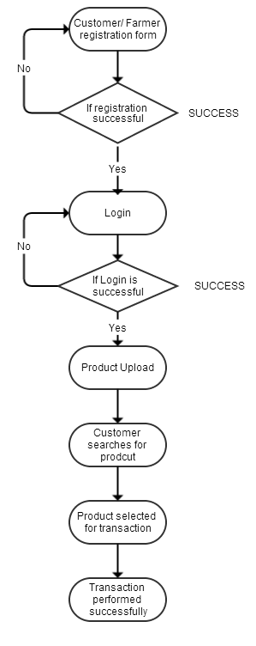

**Fig.1-Online Farming System**

# References:

1. **Website References:**
   1. <https://drive.google.com/file/d/18pfaXhfTzVYLpCnuDbmlJelnrp6faF/view> **2.**https://[www.academia.edu/37040228/ONLINE_FARMING SYSTEM_full_project _](http://www.academia.edu/37040228/ONLINE_FARMING%20_SYSTEM_full_project)  **3.**https://[www.researchgate.net/publication/371280513ONLINE_FARMING_System_Report](http://www.researchgate.net/publication/371280513ONLINE_FARMING_System_Report)
2. YouTube
3. Google

# Example of journal Paper:

* + 1. IEEE Research Paper

# Signature of Student

|  |  |  |
| --- | --- | --- |
| 1. DeshmukhRadhikaRavindra | (3043) | - |
| 2.JadhavKiranPopat | (3044) | - |
| 3.PatilSamruddhiPramod | (3045) | - |
| 4. RajmaneShruti Shankar | (3046) | - |

-

## Signature of Guide Head of Department